**海外GM添加新服操作指南Overseas GM tool operating instruction for adding new servers**

1. 目的：objective
   1. 方便海外联动商添加自己的新服到GM工具allow overseas co-publishers add their new servers into GM tool.
2. 步骤：procedure
   1. 修改原有数据源配置文件，把新的服务器数据源添加进去：modify original data source configuration files, add new server data source:
      1. 假设GM的工具路径为：/usr/local/apache-tomcat-6.0.32/webapps/gmt suppose that the patch of GM tool is: /usr/local/apache-tomcat-6.0.32/webapps/gmt
      2. 进入目录WEB-INF/ access catalogue WEB-INF/
      3. 编辑文件applicationContext.xml，如图操作：edit file applicationContext.xml,as the picture below: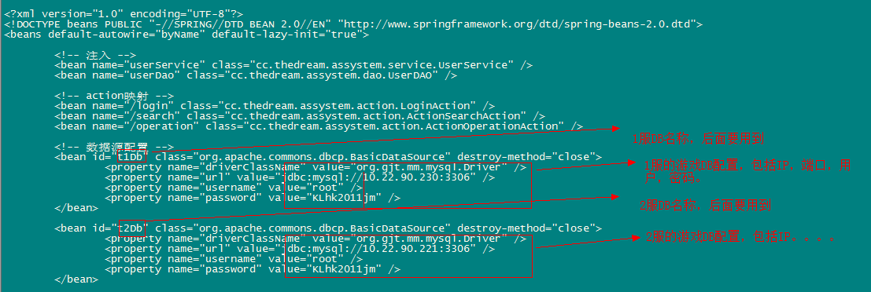
      4. 修改后保存退出，记得各服的DB名称。Save and exit after modifying, record DB name of each server.

* 1. 修改原有服务器列表文件，添加新服进去：modify original server listfile, and add new server’s
     1. 进入classes/ access classes/
     2. 编辑文件plat.conf.properties，如图所示：edit file plat.conf.properties, as the picture below:
     3. 把新服的名称、所在服务器列表位置、DB IP、刚才所配置的DB名称中间以‘－’号隔开，添加到application.serverList所在行的最后面，各服之间的配置以英文逗点隔开.add new server name, server list position , BD IP, and DB name just allocationed at the back of application.serverList, part them with ‘－’,part configuration of each server with comma.
     4. 编辑文件transport.properties，如下：edit file transport.properties, as below,

10.22.90.221=http://login.rz.wiyou.com/gmcmd.php?server=s2&cmd=

其中，前面为该服的数据库DB,后面为GM命令发送地址，其中s2表示2服，其它各服依次类推。Front is data base DB, behind is GM order send address, s2 represent Server 2.

* 1. 重启GM服务器：进入tomcat所在目录，cd bin/，执行./shutdown.sh先关闭服务器，再执行./startup.sh开启服务器，进入GM进行查看。Restart GM server: access tomcat catalogue, cd bin/, execute ./shutdown.sh, close the server , and execute ./startup.sh restart server. Access GM and check.